Iteration 2 - Proposal

1. **Situation Understanding**
   1. **Situation objectives identification:**

With the rapid development of our world, the quality of human beings’ lives, and living standards are improving to a quite high level. However, the truth is that there are still existing various kinds of problems that influence the world we are living in. In order to solve those problems, the United Nations proposed ’17 Sustainable Development Goals.’ In this case, we focus on the air quality problem, which belongs to multiple goals, such as the 3rd ‘Good health and well-being’ because of the low-quality air is harmful to us; also, the 13th ‘Climate action’ as the impurity in the air may cause the climate change – in a bad way. The objective of this case is trying to discover, find and summarize the possible pattern of the air quality data sets, and even predict the future quality of air – in other words, by utilizing those data sets and mining the underlying pattern, we may find a better way to help the world and the public to understand the change of the air that we breathe every second, and take actions to protect the air.

* 1. **Situation Assessment:**

**Sources of Task:**

**Data source**: The datasets are available from Kaggle and the Taiwan Environmental Protection Administration Executive Yuan.

**Hardware source**: Personal laptop.

**Software source**: IBM IPSS Modeler.

The current situation our air quality is not that optimal. The air quality has always been a serious problem for us, especially for Some developing country. In Taiwan, the air quality indicators, no matter the PM2.5 or PM10 or other chemicals (nitric oxide), all of them indicate that the people are breathing impurity such as ozone, different respirable particulate matters, and so on. Those impurities are no doubt harmful to human beings.

For the purpose of analysis, the air quality monitoring data is indispensable. Usually, the data file data has various kinds of type - the numerical such as numbers and dates, the categorical like locations and weather-type. In general, all the data can be used during the analysis process. However, the risk of this is, the data we used is not always ‘clean,’ and this unclean situation may lead to the inaccurate model generation which is used to make prediction – if the model we have is not accurate, consequently, the predicted results are also not precise, in some special occasion, this inaccuracy may cause serious consequence. The possible solution is, at the very beginning we will execute the operation ‘data cleaning,’ and we will try several different algorithms to make sure that we can generate the optimistic model in a certain way.

* 1. **Data Mining Objectives:**

In general, the goal is to find the potential pattern among the attributes and try to find a way to make a prediction and even get a way to control the air pollution.

To help our society to understand the air quality data, we need to analyze the oceans of past monitoring air data. The data mining objectives are mainly focused on finding the different types or kinds of relations between the numerous data attributes. By analyzing those data, such as the different numbers of different indicators in various time slots. We may find and summary a pattern that when the air pollution is most serious, and which kind of pollutant contributes the most. During the mining process, several different algorithms may be utilized to test for some diverse model, and finally, choose the one who can describe the past data and optimally predict the future air quality.

* 1. **Project Plan:**
     1. **Project Background**

As above, to achieve the United Nations’ sustainable development goals – ‘Good health and well-being,’ and ‘Climate action,’ the society need to pay more attention to the air that is crucial and indispensable for us. Based on this, we need to collect, process and then analyze the air quality monitoring data about the past. After analysis, expectable we will get a pattern of these data, and ideally, we can utilize this model/pattern to predict the future air quality and also, take action on air quality control to provide a better environment for human beings.

* + 1. **Tasks**

|  |  |  |  |
| --- | --- | --- | --- |
| **Phase** | **Time (ETA)** | **Resources** | **Risks** |
| Situation understanding | 6 hrs. | Data analysts | Environment change, criteria change |
| Data understanding | 12 hrs. | Data analysts | Data problems, technology problems |
| Data preparation | 1 day. | Data analysts, and specific software/tools | Data problems, technology problems |
| Modeling | 1 day. | Data analysts, specific software/tools | No model can fit the requirements |
| Evaluation | 6 hrs. | Data analysts | Environment change, criteria change |
| Deployment | 3 hrs. | Data analysts | Environment change, criteria change |

1. **Data Understanding** 
   1. **Initial Data Collection:**

In this phase, we will collect the data sets that we need to perform data mining operation. There are plenty of ways for us to gather data – for an organization, the data within the organization should be collected in terms of the current data; also, sometimes we may need to purchase additional data from organizations because our data set is incomplete. If still there are not enough data sets, we need to research and add more data to the data sets.

There are thousands of websites (governments, organizations and so on) provide the data sets to download. In this case, the data can be collected from the official websites or other specialized data sets websites such as Kaggle. For this task, the data sets we collected in this case, it was downloaded via Kaggle.

* 1. **Data Description:**

Dataset Scale: 23 attributes, nearly 220k records.

|  |  |  |  |
| --- | --- | --- | --- |
| Attributes | Description | Type | Role |
| Time | Time records | Continuous | None |
| Station | The station that recorded the data | Categorical | Input |
| AMB_TEMP | Temperature | Continuous | Input |
| CH4 | CH4 index | Continuous | Input |
| CO | CO index | Continuous | Input |
| NMHC | Non-methane hydrocarbons index | Continuous | Input |
| NO | NO index | Continuous | Input |
| NO2 | NO2 index | Continuous | Input |
| NOx | NOx index | Continuous | Input |
| O3 | O3 index | Continuous | Input |
| PH_Rain | The PH value | Categorical | Input |
| PM10 | PM10 index | Continuous | Target |
| PM2.5 | PM2.5 index | Continuous | Target |
| Rainfall | Rainfall index | Continuous | Input |
| Rain_Cond | Conductivity index | Continuous | Input |
| RH | Relative-humidity index | Continuous | Input |
| SO2 | SO2 index | Continuous | Input |
| THC | Total-Hydrocarbon index | Continuous | Input |
| UVB | UVB index | Continuous | Input |
| WD_HR | Wind direction/hour | Continuous | Input |
| Wind_Direction | Wind direction | Continuous | Input |
| Wind_Speed | Wind speed | Continuous | Input |
| WS_HR | Wind speed/hour | Continuous | Input |

Considering the methods of air monitoring, the air quality records will be a large number. The scale of our data set has 23 columns and approximately 220k records, and it stored in a CSV file, in order to make our research more convenient we transfer it to xlsx file. The majority of the value types are numerical and categorical, such as date, time, numbers, location, and so forth.

The IPSS Modeler is used to discover the dataset. The data audit node can be used to censor the dataset information and data quality. Below is the screenshot of audit result.

* 1. **Data Exploration:**

The IPSS Modeler is used to discover the dataset. The data audit node can be used to censor the dataset information and data quality. Below is the screenshot of audit result.

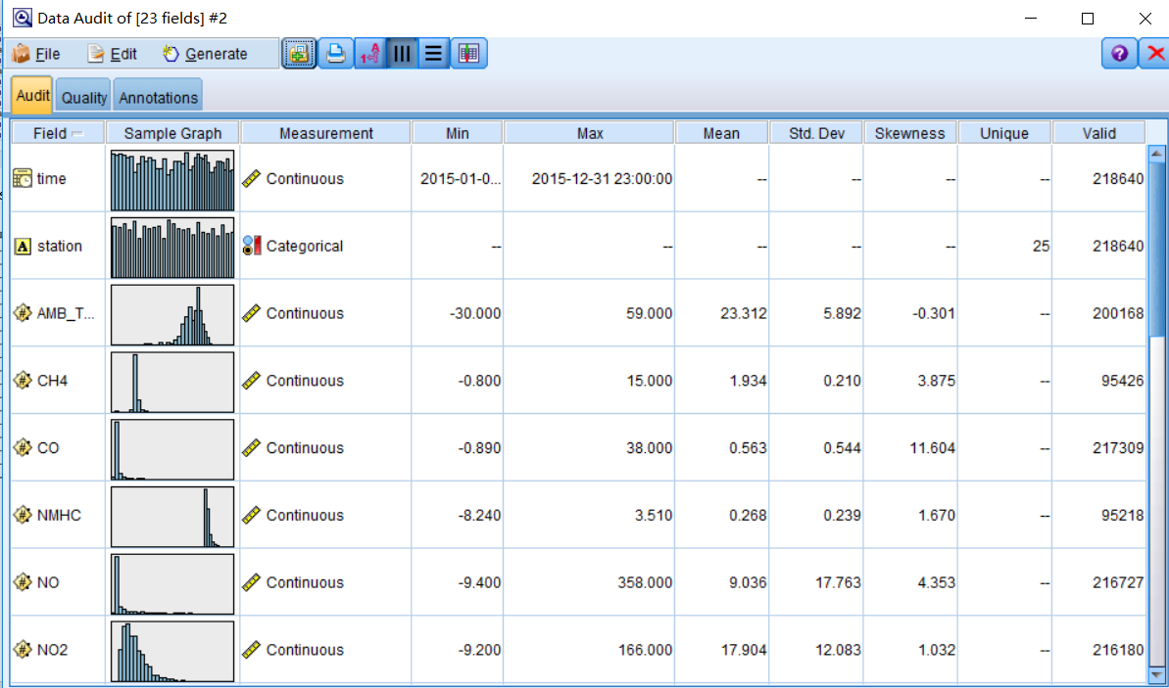

SC1-Data Audit Results

Here we can notice, the data set is not very ‘clean’ – some attributes have too many missing values, also, some negative values appear in the attributes that should not be. So, we will have to do the ‘clean’ later.

By using the ‘Graphboard’ node, we choose all the attributes except ‘time,’ and then we run the ‘Parallel’ graph, below is what we got.

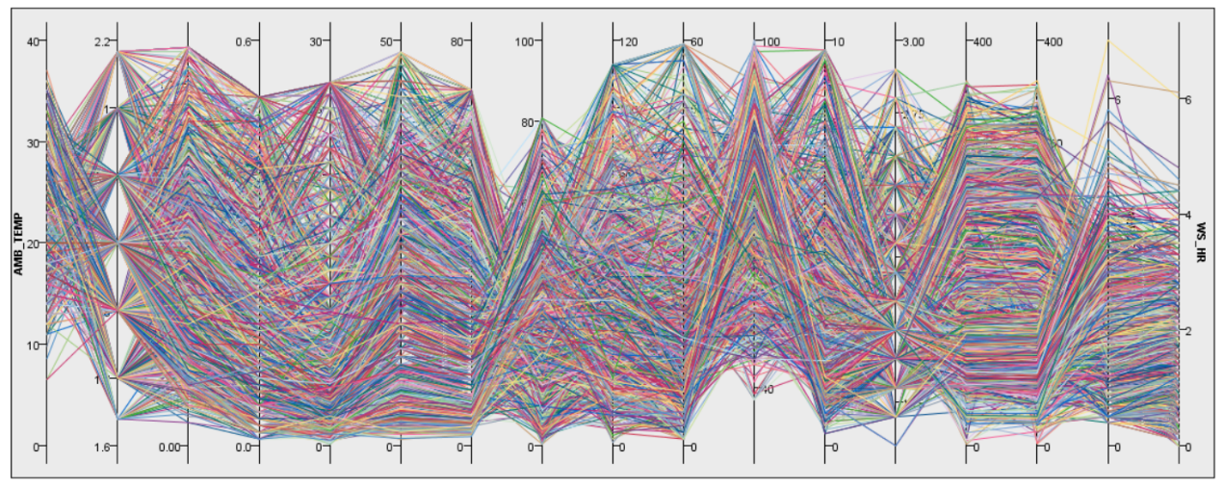

Parallel graph with all attributes

In order to explore the dataset, some graph nodes are connected to the dataset node. To begin with, we assume that the temperature and the PM indexes may have some relationships, so we use the scatterplot graph to explore.

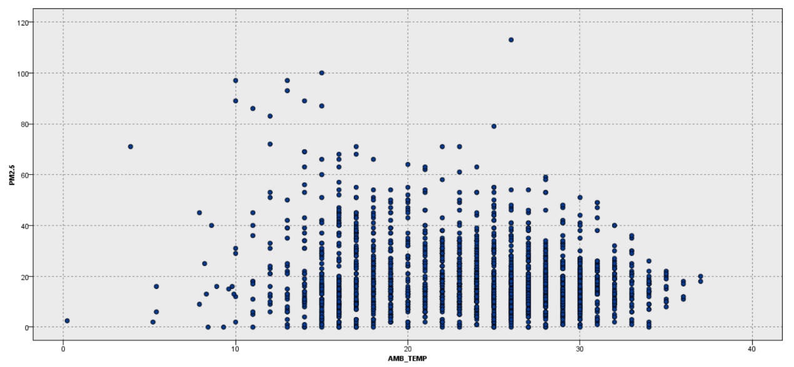

PM2.5 – Temperature Plot Graph

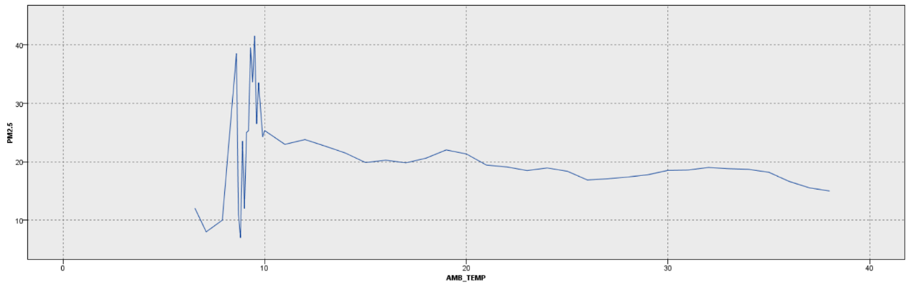

PM2.5 – Temperature Line Graph

From this graph, we cannot have a clearly view about the relationship between temperature and PM value.

Additionally, we considered that the wind speed might also influence the value of PM, so we made another graph.

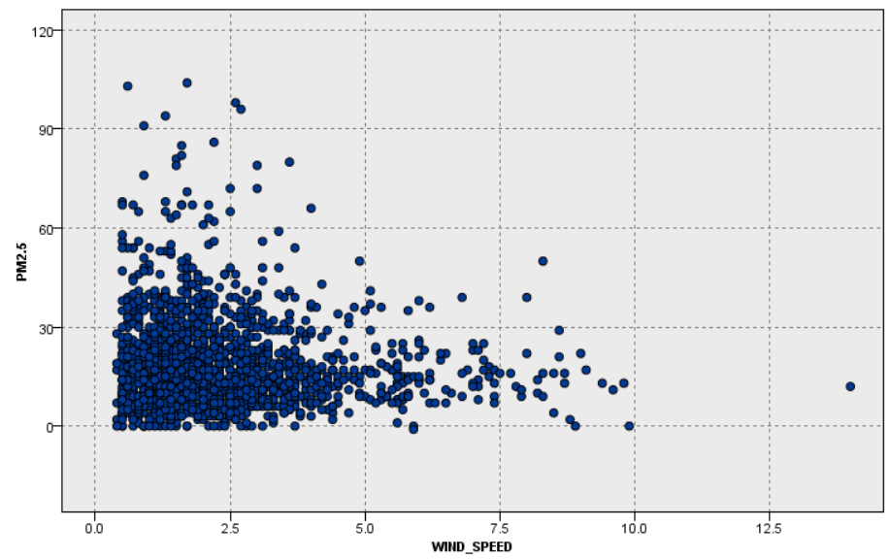

Wind-Speed – PM2.5

Based on the graph, roughly we can say that the higher speed of wind usually has a lower value of PM.

Also, we want to see the relationship between time and PM2.5, so we made another graph.

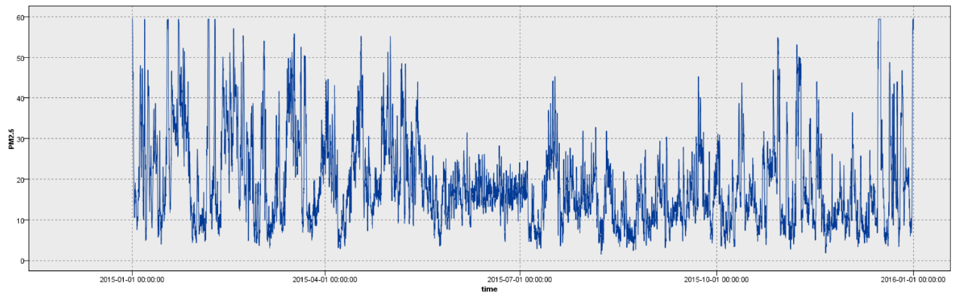

We can infer that at some time periods, the PM2.5 value is higher than other time.

* 1. **Data Quality Verification:**

The dataset with a huge amount of records is always not perfect. There are a lot of unexpected data errors within the data set, in our air quality of Taiwan file, there are some missing values, and in some attributes, the values are mixed with multiple types of data, and some records seem are not correct. All of those phenomena are not good for our data mining operation. For a better data mining result, the data set needs to be ‘cleaned.’ Within this dataset, there are some attributes have missing values, and in order to further discover the dataset, we can use the boxplot graph to find the outliers.

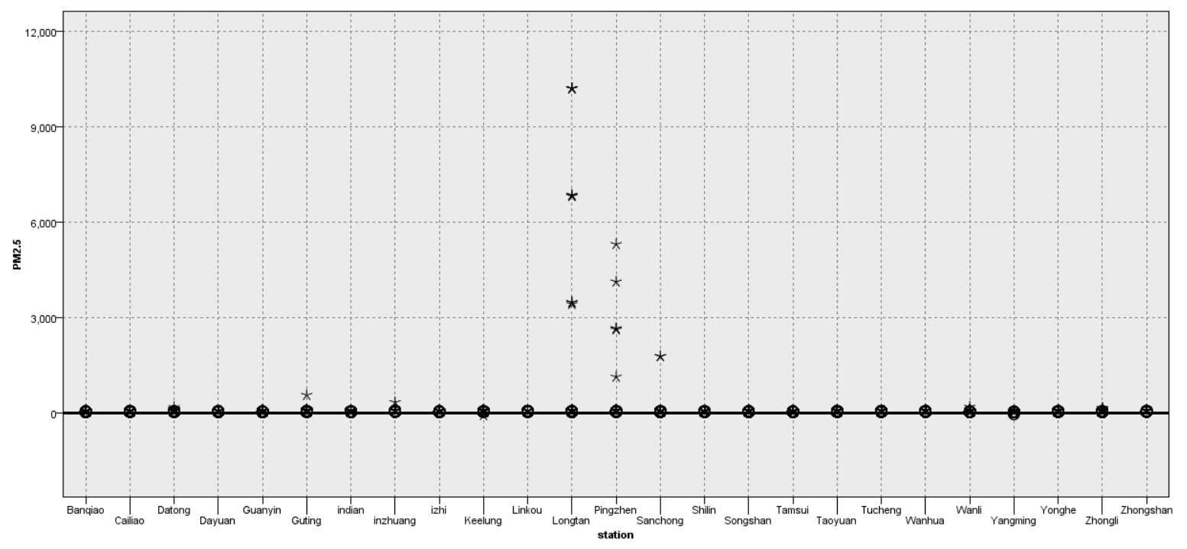

Station-PM indexes Boxplot

From the chart, we can see there are some of the values are abnormal, but most of the quality of statistics are acceptable.

Furthermore, by using the ‘Data Audit’ node, we can easily observe the dataset. We connected the ‘Data Audit’ node with the source node, and then we can get the result. In the ‘Quality’ interface, we can specify the operations that we want to deal with the outliers, extremes, and missing or null values.

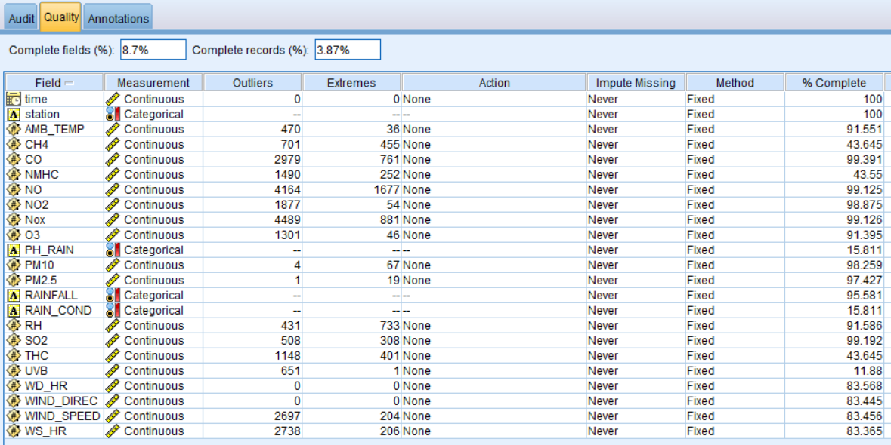

Data Audit Results

So, we need to deal with the outlier and extreme values, and the incorrect negative values.

1. **Data Preparation**
   1. **Data Selection**

We connected ‘Table’ node to the source node so that we can have a general view of the dataset. We import the dataset file into the ‘Excel’ node and run the ‘Table’ node, below is the result.

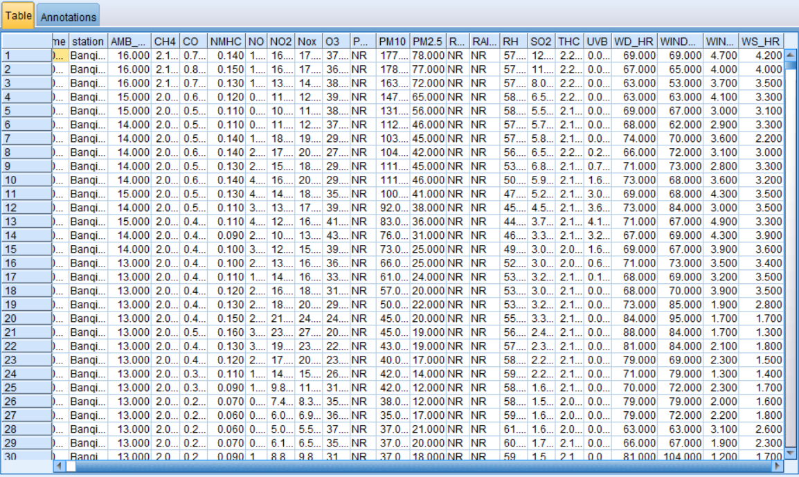

Table-Node Detail (23 attributes, 220k records)

From this table, we know that some of the attributes have too many unknown values (null or missing values). The PH_Rain, Rainfall, and Rain_Cond had too much ‘NR’ values which mean these three attributes can be considered as useless columns. Hence, we will not take them into our data-mining process. Meanwhile, the other attributes also have some missing values, but in an acceptable range.

* 1. **Data Clean**

After the data selection phase, now we are going to clean the dataset. From the data audit node, we can notice that most of the attributes’ values are valid, and so we can discard those missing values because they will not have a significant influence on the dataset. However, there are a few attributes seem to have too many missing values, if we delete all the missing values, it may cause some unpredictable consequences, so we need to use other methods to deal with them.

At first, we will filter the null values within some attributes by the ‘@NULL ()’ function.

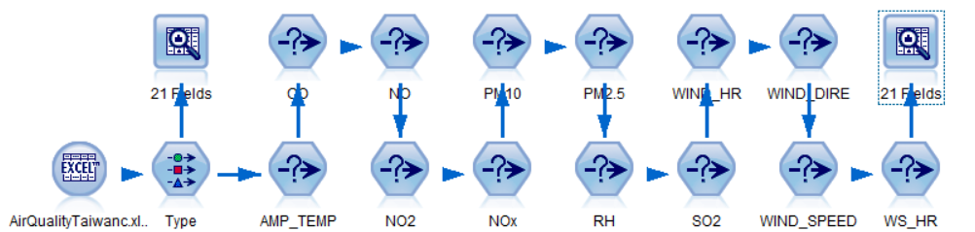

Initial data clean process by ‘Select’ node.

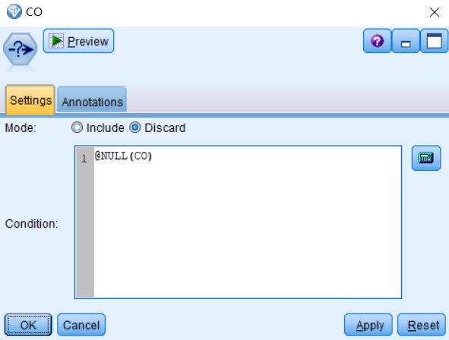

Null Value Discard Example

After these ‘Select’ operations, some of the missing values will be discarded. Below are the results after the initial process.

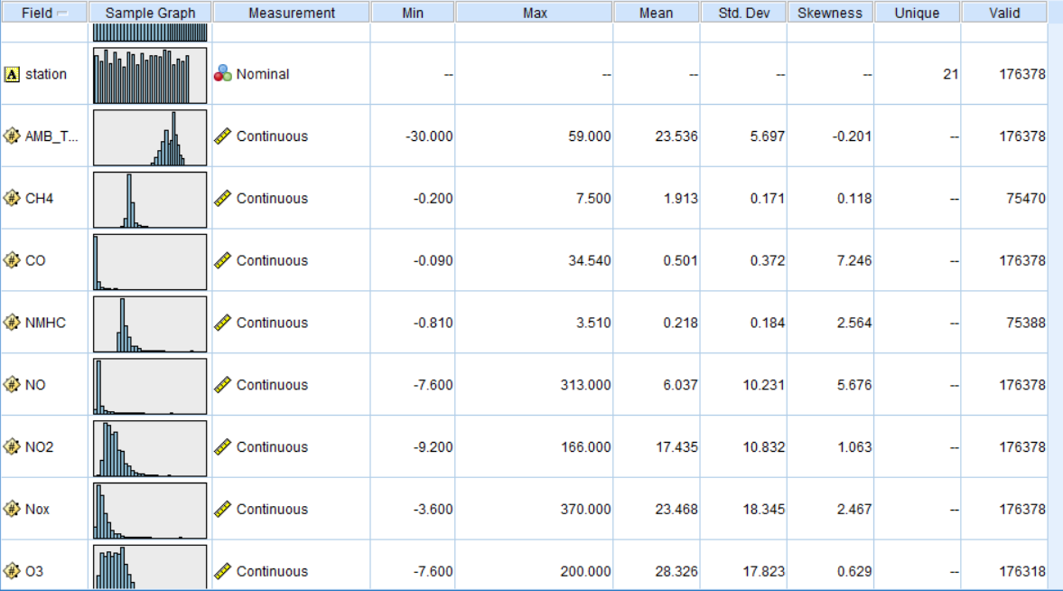

Data Audit Results

We can notice that there are some negative values that should not be presented, so we decide to discard them. We can also use the ‘Select’ node to achieve this.

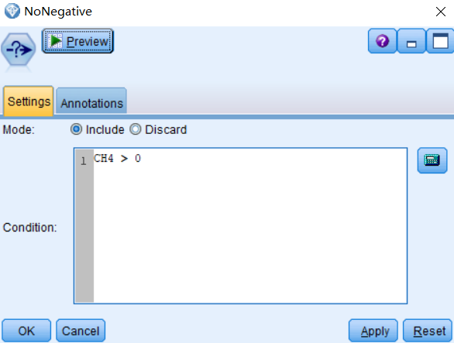

Discard all the negative values

Next, we will deal with the rest of the attributes with the ‘SuperNode.’ Clicking the ‘Quality’ tab in the ‘Data Audit,’ we can see the table has already listed the outlier, extreme values, and missing values. There are some available actions to deal with them – ‘Discard,’ ‘Coerce,’ ‘Nullify,’ ‘Coerce outliers/Discard extremes,’ ‘Coerce outliers/Nullify extremes.’ Here we assign different methods to the attributes that depend on their situations.

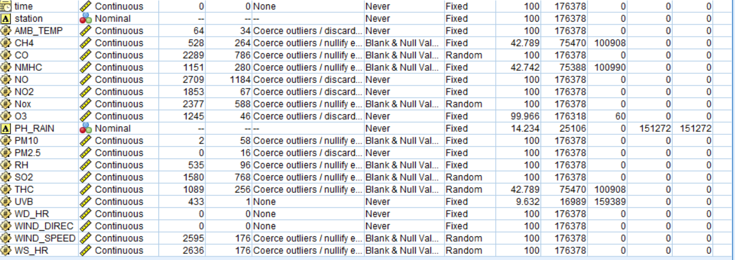

Outliers/Extremes/Missing Values Processing

Then we click the ‘Generate,’ generating the missing value supernode and outlier/extreme supernode.

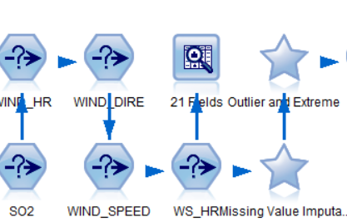

Supernodes

* 1. **Data Construction**

To construct the data, first, we observed that some of the attributes are missing too many values, and even if we utilize the impute-missing-value operation, the results might be not accurate, so we decide to use the ‘Filter’ node to delete them.

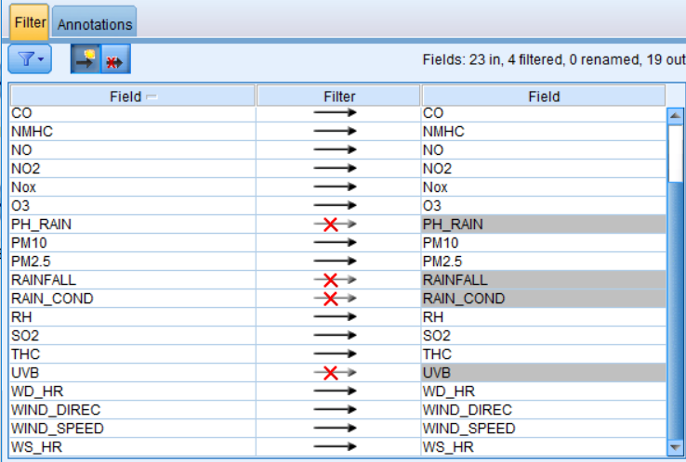

Filter Node

* 1. **Integrate Data Sources**

As we only have one dataset that is stored in one single CSV file, so we do not need to use the ‘Merge’ node which integrates several files together. The source file is imported at the beginning.

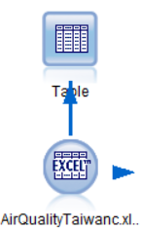

Source Node

1. **Data Transformation**
   1. **Reduce the Data**

By the observation of the dataset contents, we found that some attributes have too many blank values (‘NR’) or Null values, and compared to the entire dataset these attributes cannot be easily ‘imputed’ or ‘processed’ with the assurance of data quality. To make sure the accuracy of further data mining process, we decide to ‘abandoned’ these attributes – reducing the dataset.

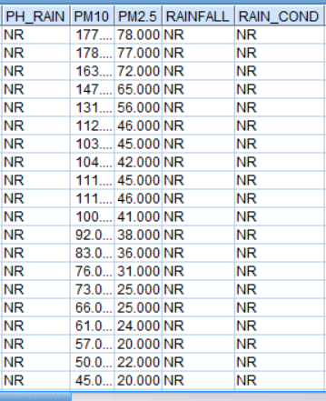

‘NR’ Values Example

We can use several methods to solve them – such as ‘Select’ node or ‘Filter’ node.

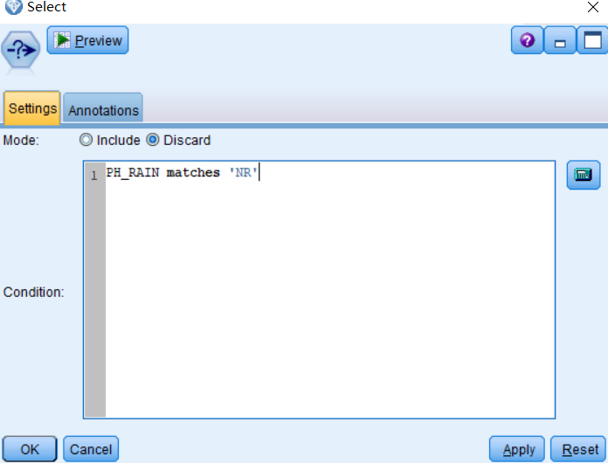

Select Node

The ‘matches’ can be used to filter the values that we specified, in this case, the ‘NR’ value is the blank value which we want to discard. To some extent, we can reduce some noisy data through the data reducing phase.

* 1. **Project the Data**

In this phase, we connect the ‘Partition’ node to our stream. This node can divide the dataset into several parts – training, testing, and validation part. Here we assign 70% for training, 25% for testing and 5% for validation. By using this node, we can have a better understanding of our model.

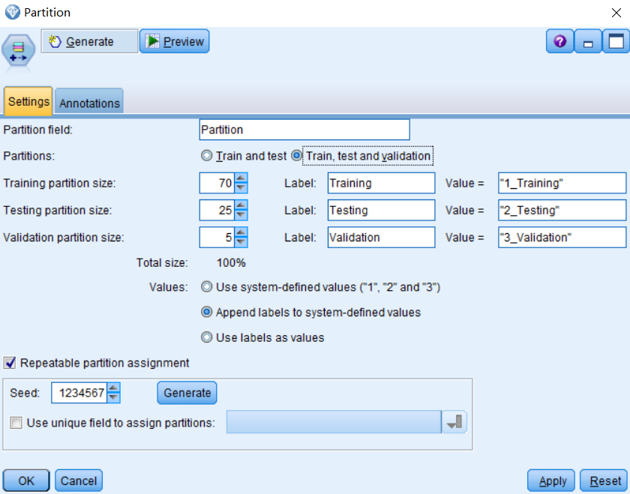

Partition node

1. **Data-mining Method Selection**
   1. **Match and discuss the objectives of data mining to data mining methods**

In this case, our goal is discovering the relationship between the various kinds of chemicals in the air and the PM values. In addition, we want to know whether we can predict the PM value if we have the other pollutants’ values, they are our objectives. In general, there are three types of methods – classification, clustering, and regression. The classification is the task of approximating a mapping function from input variables to discrete output variables, its output is usually named label, some classical classification algorithms such as Naïve Bayes, decision tree, and support vector machine. The regression is the task of approximating a mapping from input variables to a continuous output variable, in other words, numeric values. The classical regression algorithms include linear regression, regression tree, and logistic regression. The clustering method is unsupervised algorithm, if we don’t know our target yet, we can use the clustering, such as K-mean algorithm, Kohonen algorithm, Hierarchical clustering, and Gaussian mixture model.

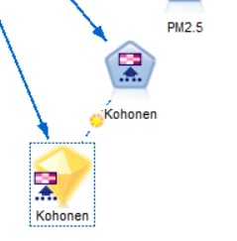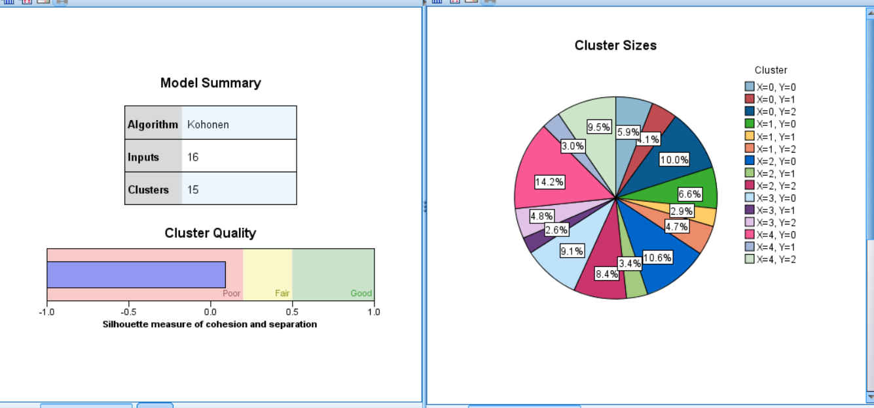

Kohonen Clustering

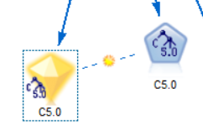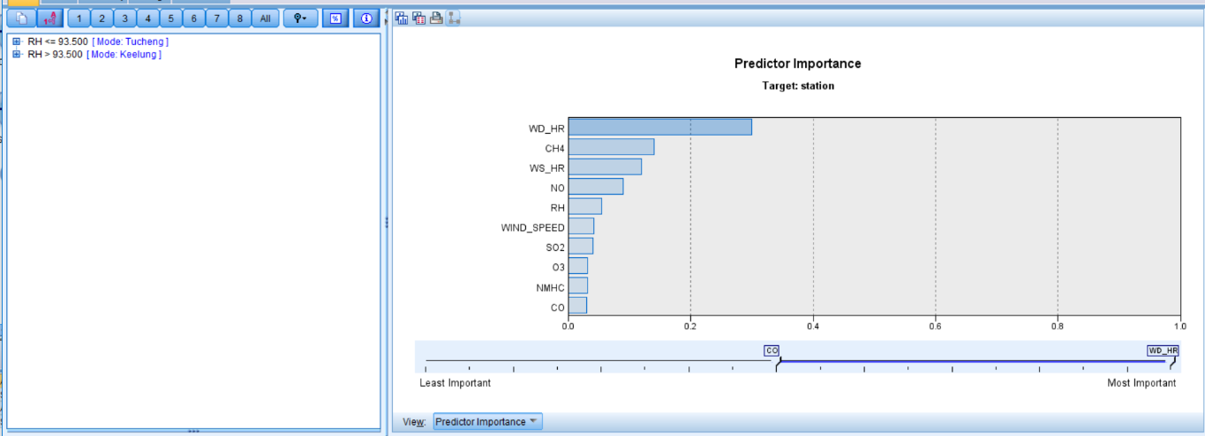

C5.0 Classification Algorithm

These screenshots show the clustering and classification algorithms, we can see the clustering quality is poor. In this case, the dataset is numeric, hence, the regression algorithm will be the best fit for our data mining process.

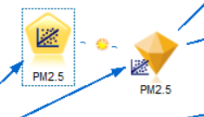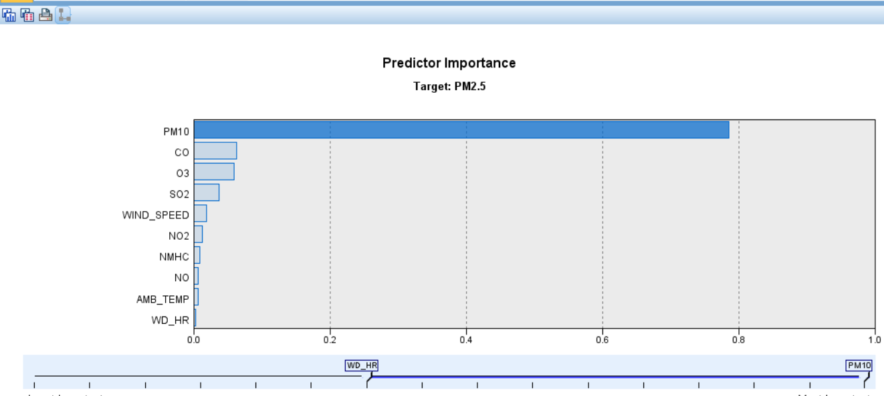

Regression Example

* 1. **Select the appropriate data-mining method(s) based on discussion**

Within the SPSS Modeler, we can find a lot of different algorithms under the ‘Modeling’ tag.



Algorithms

There are plenty of regression algorithms such as Bayesian linear regression, boosted decision tree regression, linear regression and so on. Also, under the auto numeric node, it provides a collection of regression algorithms for us, which is convenient to model. As the discussion above, the clustering and classification are both not very suitable for this dataset, so here I choose the regression algorithms, from the simple linear regression, to the neural network, I will try different regression algorithms and find a better one based on their results.

1. **Data-mining Algorithm(s) Selection**
   1. **Conduct exploratory analysis and discuss**

In this phase, we can use the ‘Statistics’ node to discover the information about our numeric values.

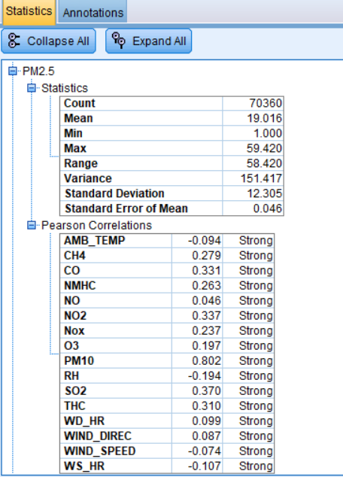

Statistics Node

From the screenshot above, we can notice that the attributes have strong Pearson correlations with our target PM2.5, in other words, we can try the regression methods for our data mining process.

* 1. **Select algorithms**

First, we will use the ‘Regression’ node to perform a linear regression model. As our target attribute is continuous, then we will try to use the ‘Auto numeric’ node to execute several models together – not only the regression models, such as neural network, generalized linear regression, and random forest, which is based on the decision tree.

* 1. **Build/Select appropriate model(s) and choose parameters**

Now we will start running our models. To begin with, we need to attach all the necessary node.

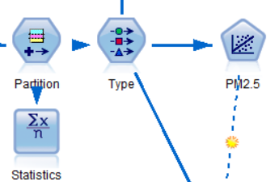

Regression Algorithm

Below is the linear regression model, we attach the ‘Regression’ node to the ‘Type’ node, and we define the role of each attribute in the ‘Type’ node.

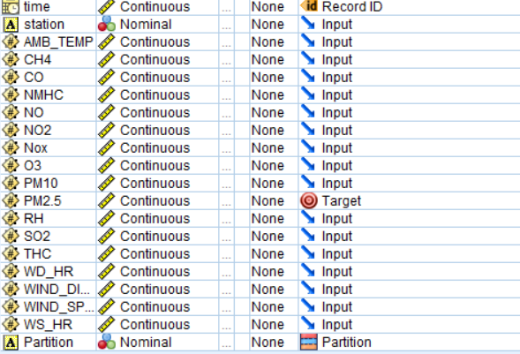

Type node

First, we set the PM 2.5 as our target, and then we edit the ‘Regression’ node.

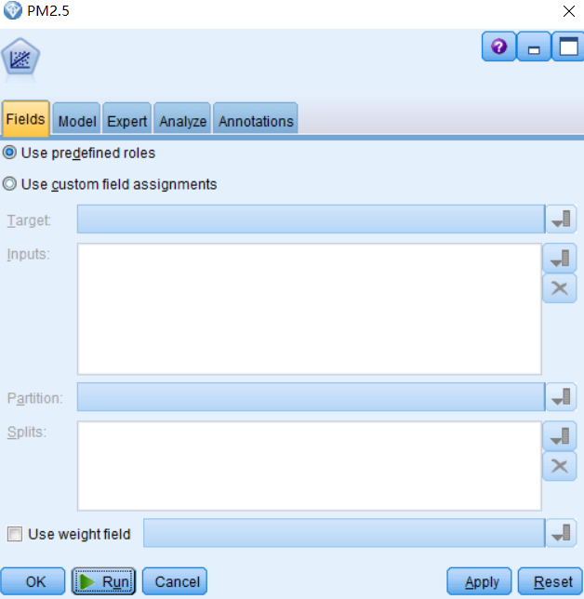

Regression node setting

As we can see, because we already define the roles of our attributes, so here we can directly use the ‘predefined roles,’ then we click ‘run’ and wait for results.

1. **Data Mining**
   1. **Create and justify test designs**

The ‘Partition’ node can provide such function for us. It is used to separate the dataset to different subsets, training, testing and evaluation. By using this, we can avoid the ‘overfit’ phenomenon at a certain degree, that would make the entire design has a more solid result. I separated the dataset into three parts – training, testing, and validation. This design will help us to understand how well or bad our models are.

Also, going through the previous steps, my model has data exploration, visualisation, and data cleaning, which follows the KDD process and it will provide us a reliable data mining experiment design. Besides, this data mining process is not an one-off work, it is iterative, which means I can improve the process in the future. Hence, this experiment design is reliable.

* 1. **Conduct data-mining – Classify, Regression, Clustering**

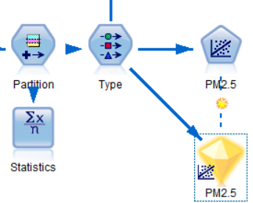

Regression result

After running ‘Regression’ node, now we got the linear regression result.

Next, we run the ‘Auto Numeric’ node; we will choose three models out of the 17 models in total.

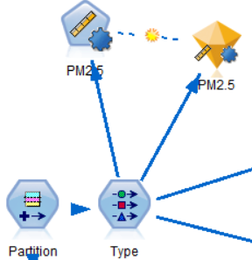

Auto Numeric Node

* 1. **Search for patterns**

First, we double-click the result node of regression, and then we check the result.

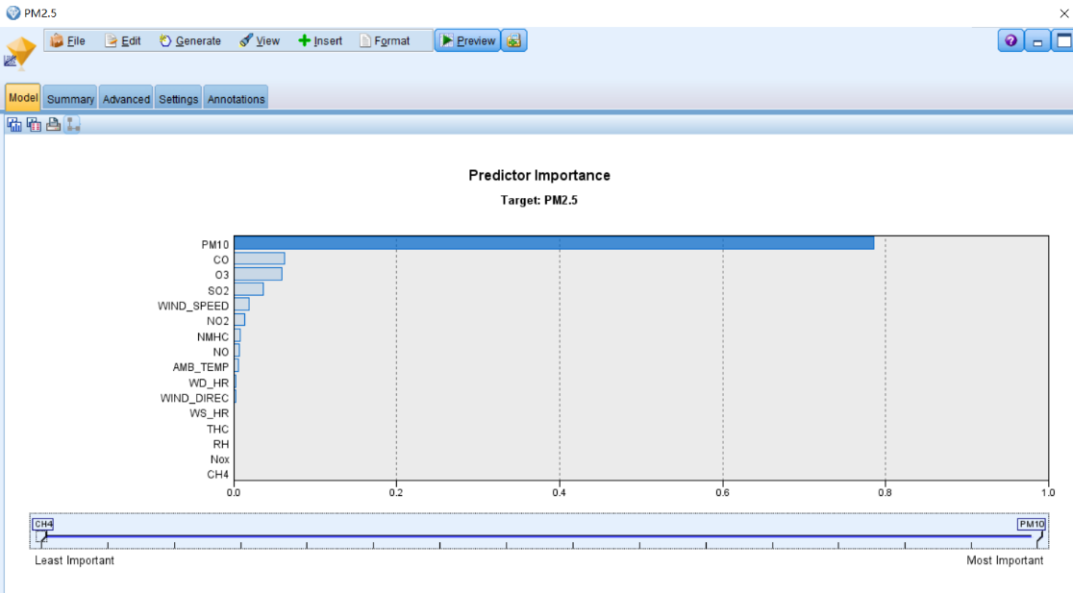

Result – Predictor Importance

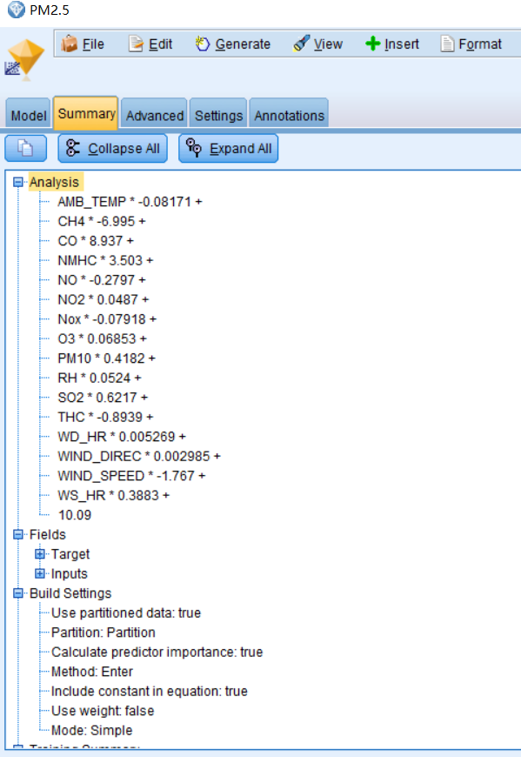

Result - Summary

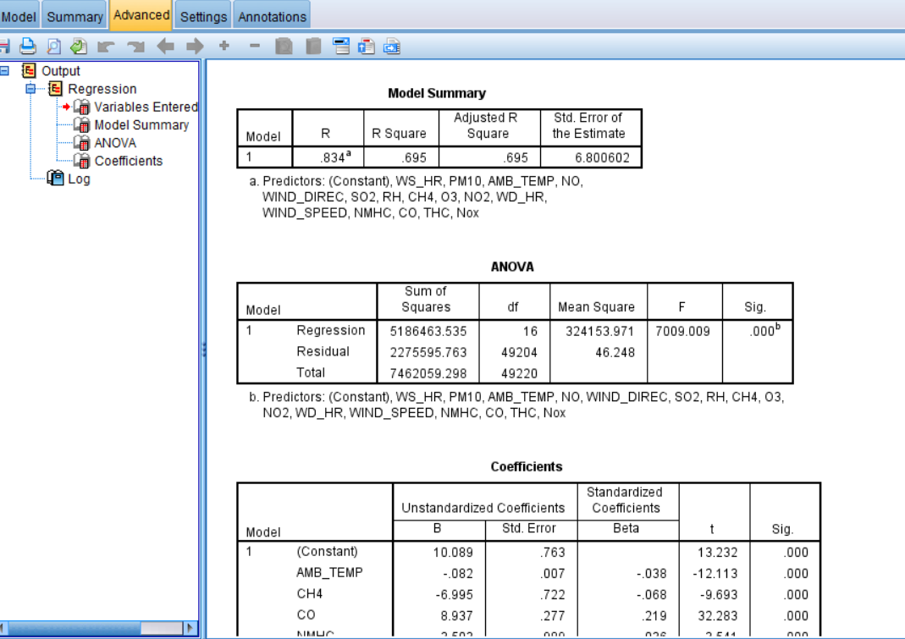

Result – Advanced Details

Below are the screenshots of the Regression model that we may find some patterns, next we will discover the ‘Auto Numeric’ result.

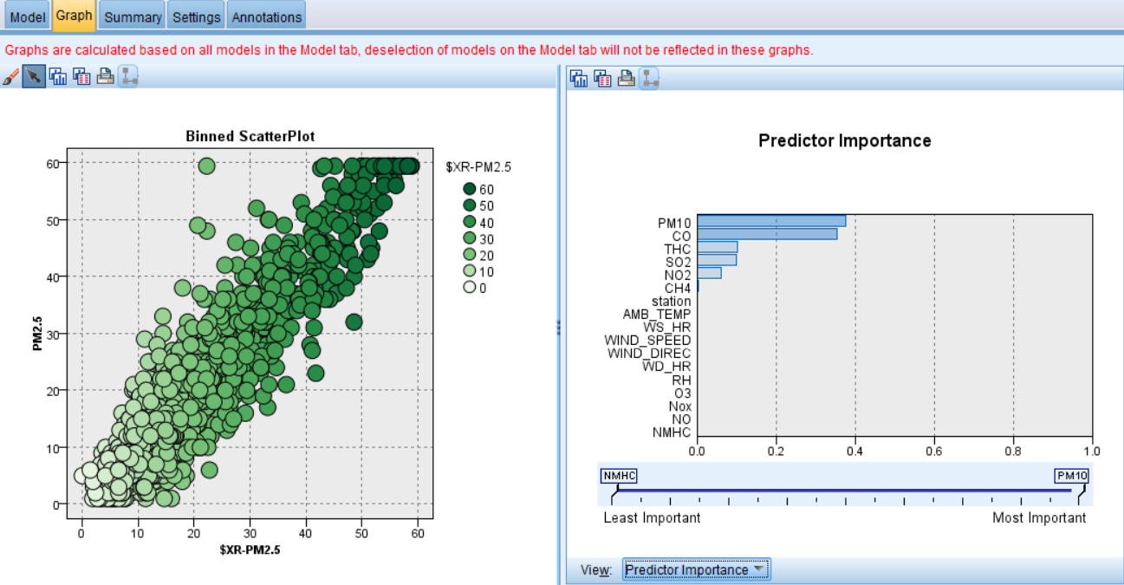

Auto Numeric Result - Graph

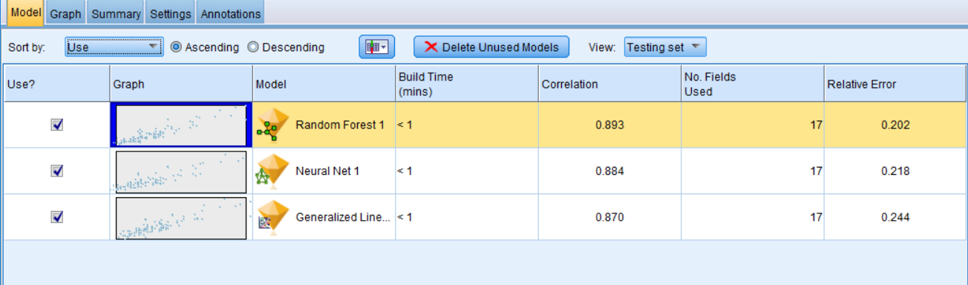

Auto Numeric Result

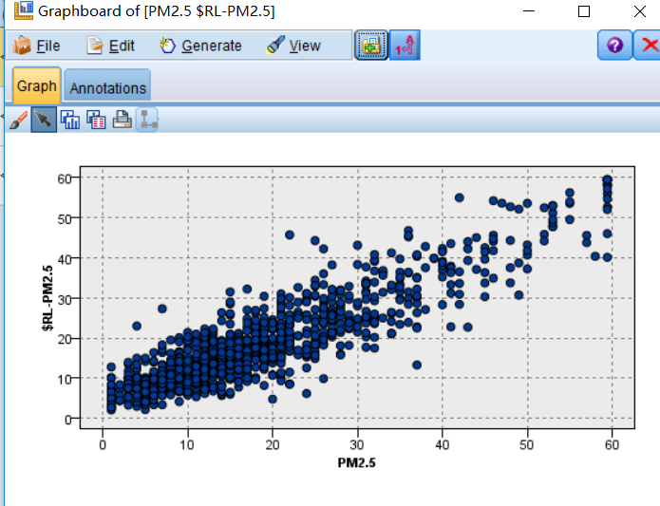

Random Forest Result Graph

1. **Interpretation**
   1. **Study and discuss the mined patterns**

For both the regression model and ‘Auto numeric’ summary, we can see that the most important predictor is the PM10 and CO. It is reasonable because we can imagine if the PM10 is high, then there is a high probability that there are plenty of microscopical materials in the air. However, because there is a high correlation between the PM values, so actually, deleting the PM10 attribute or setting it with the role ‘None’ will not have a significant influence on our further prediction. In the linear regression model, O3, SO2, and Wind_speed are relatively important for predicting the PM2.5, as for the ‘Auto numeric’ result, THC (Total-Hydrocarbon index), NO2 and SO2 are important. So, to some extent, we can say that if there are more chemical pollutants in the air, the PM2.5 will have a higher value, and if the wind speed is relatively high, the PM2.5 value will stay at a lower level.

Based on the information we got, we can infer that if we want to improve our air quality, we need to pay more attention to the different kinds of chemicals in the air, and also,

* 1. **Visualize the data, results, models, and patterns**

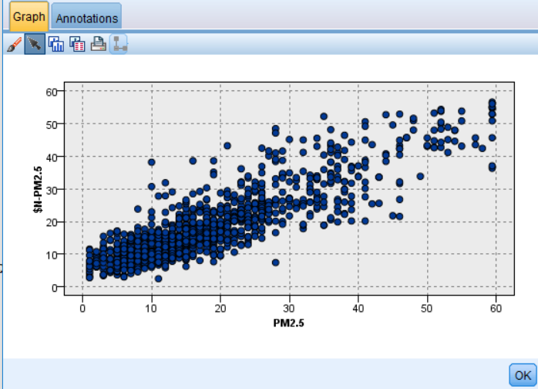

Neural Network Result

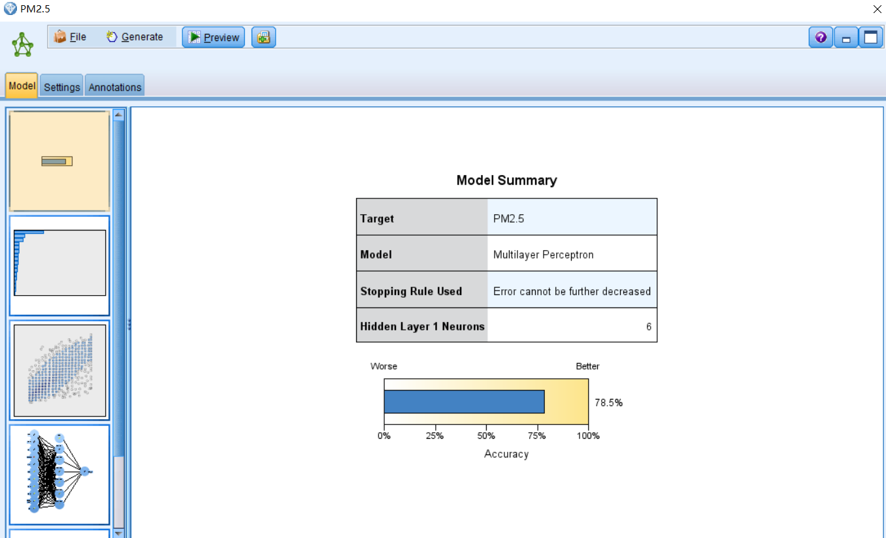

Neural Network Model Result

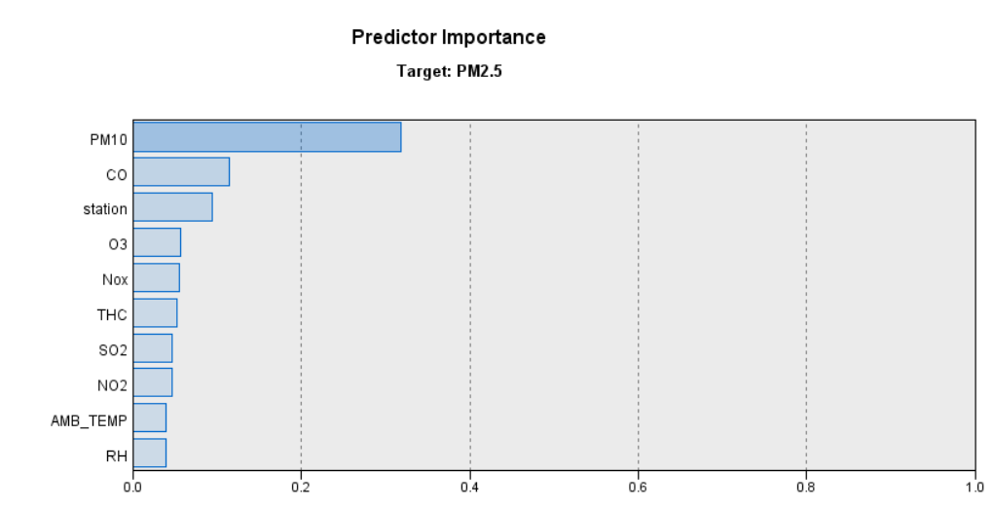

Neural Network Predictor Importance



Random Forest Result

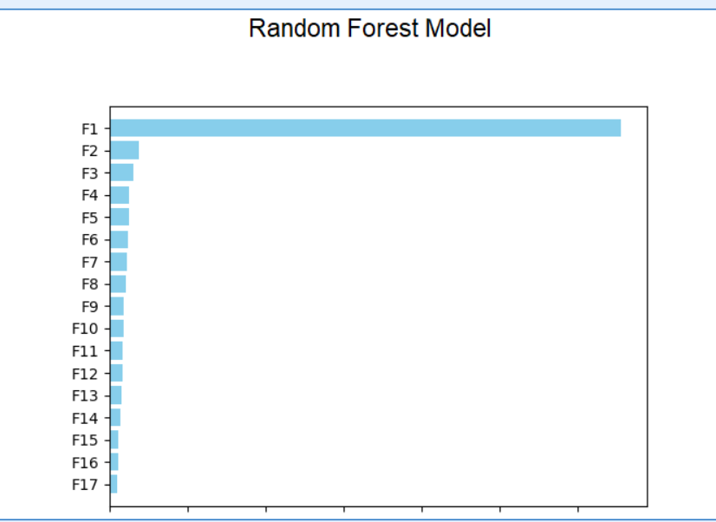

Random Forest Model Predictor Importance

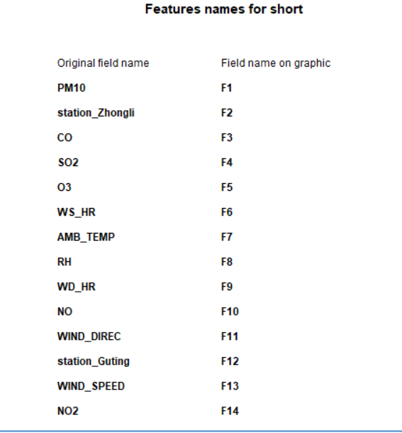

Random Forest Model Predictor Importance

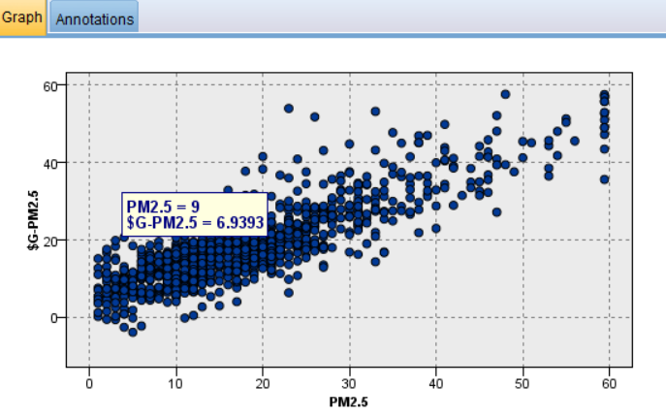

Generalized Linear Result



Model

We can see that the Random Forest model has the best accuracy, while the rest two models are not bad either.

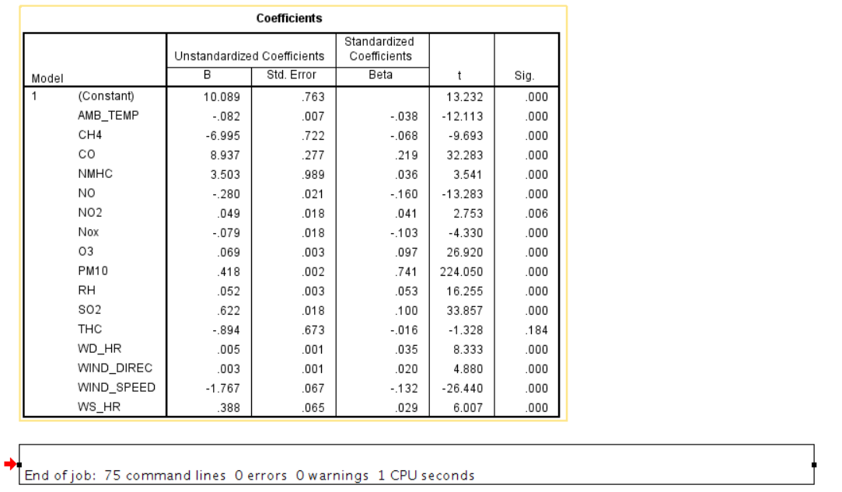

Regression Model

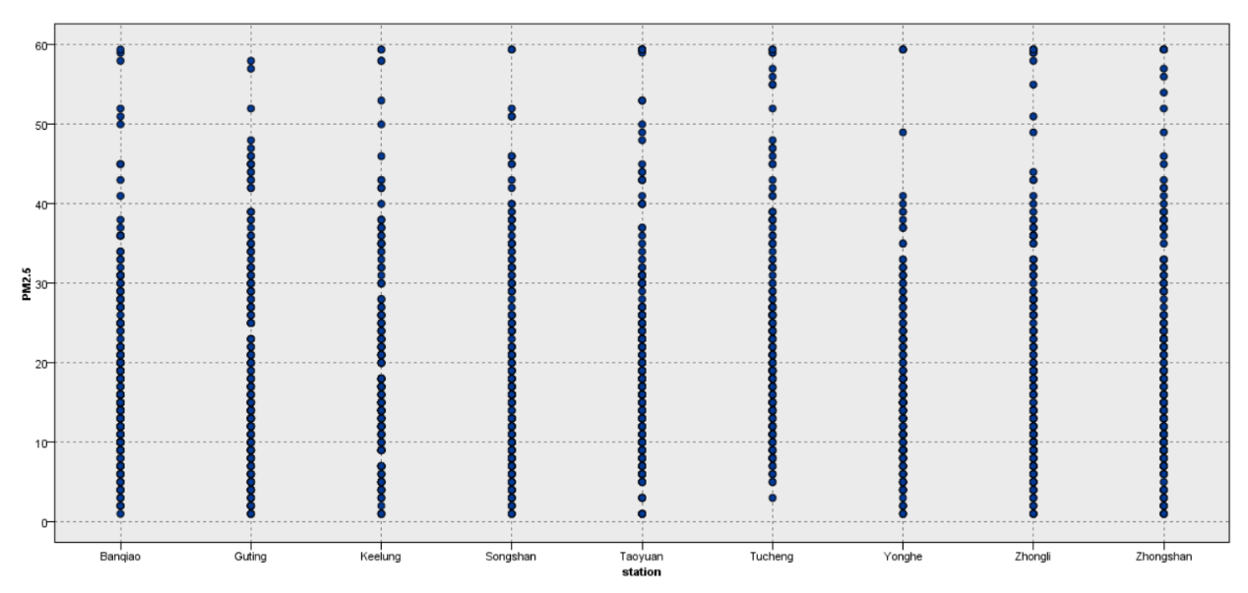

PM2.5 - Station

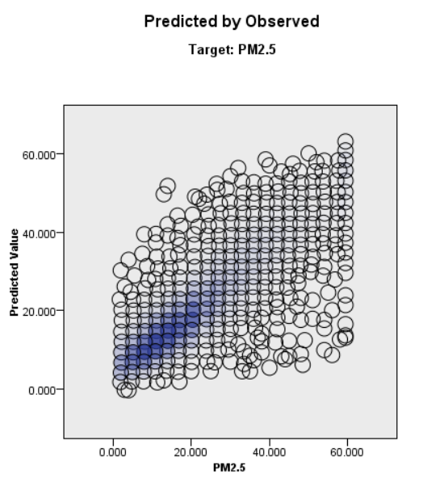

Neural Network – Predicted Observed

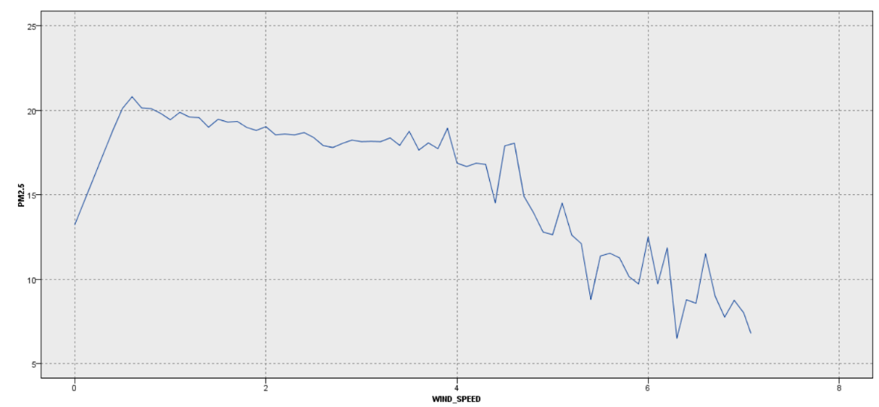

Wind Speed – PM2.5

* 1. **Interpret the results, models, and patterns**

In this phase, we will interpret these models. From the different models we can infer that, first, if there are more chemical pollutants in the air, especially the CO, SO2, O3, THC, the PM2.5 value will increase to a high level; second, if the wind speed is relatively high, the PM2.5 value will decrease.

For the linear regression model, the rank of predictor importance is PM10>CO>O3>SO2>Windspeed>NO2>NMHC>NO>Temperature>other factors. It is reasonable enough for us to understand, and also, it is useful for our environmental control department. For example, we can see that CO has a serious impact on the PM2.5, so the environment department now has a clue – figure out the where does the CO come from, and how it be produced and exhausted into the air. Such model indicates the things that influence our air quality.

It is reasonable enough for us to understand, and also, it is useful for our environmental control department. For example, we can see that CO has a serious impact on the PM2.5, so the environment department now has a clue – figure out the where does the CO come from, and how it be produced and exhausted into the air. Such model indicates the things that influence our air quality. Also, we can utilize the different ‘contribution’ of air pollution from the various kinds of chemical pollutants to make up a specialized plan, which will solve the air problem based on the importance of predictors one by one.

In this case, we need to care more about the CO, SO2, and O3, as they are the predictors contribute the most.

* 1. **Assess and evaluate results, models, and patterns**

In order to assess our results, we can use the ‘Analysis’ node and the ‘Evaluation’ node.

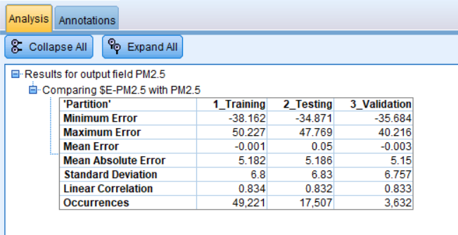

Regression Analysis

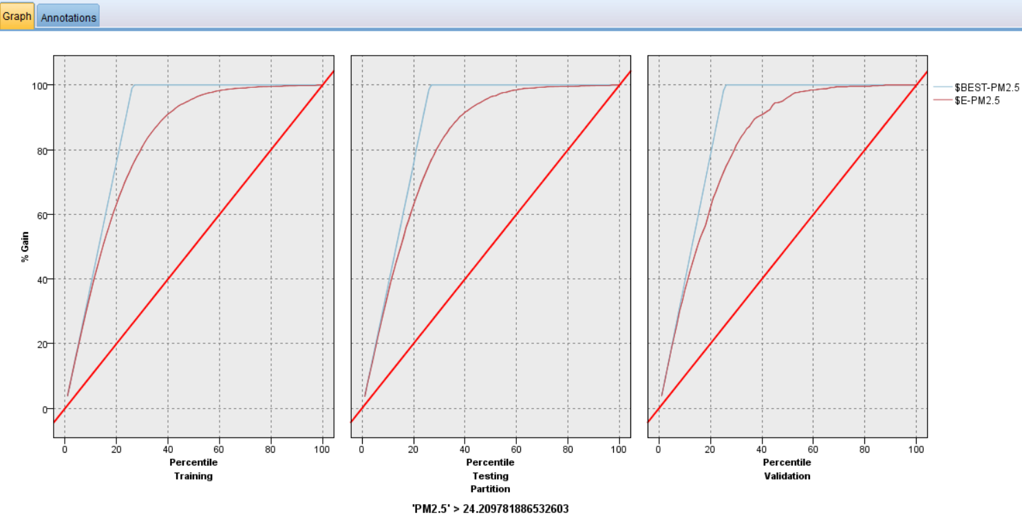

Regression Evaluation

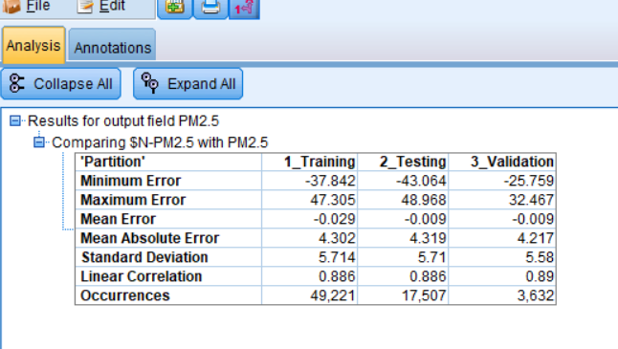

Neural Network Analysis

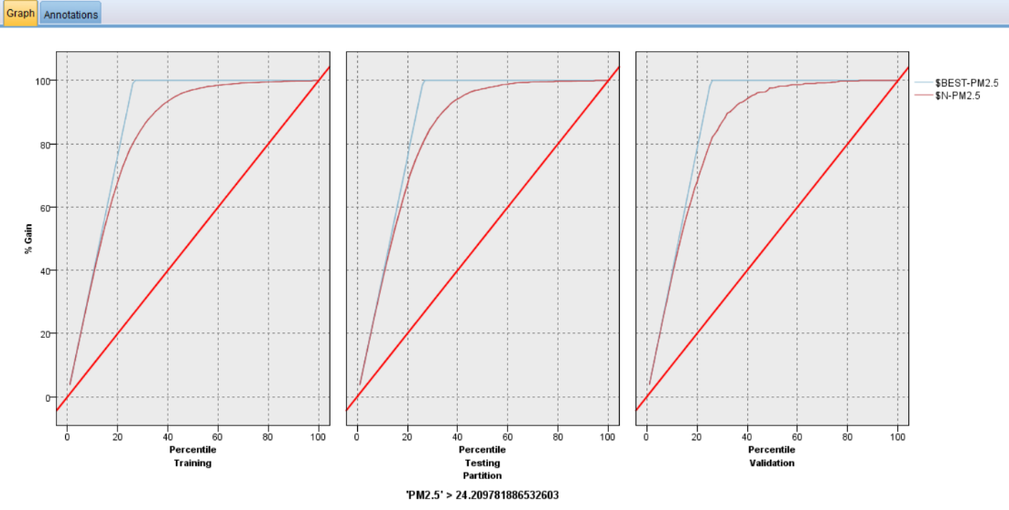

Neural Network Evaluation

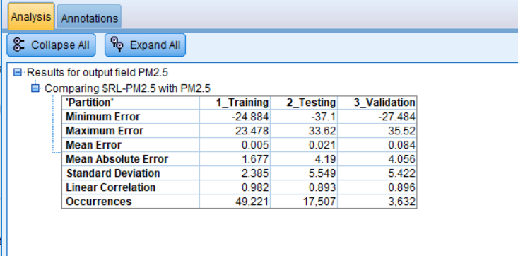

Random Forest Analysis

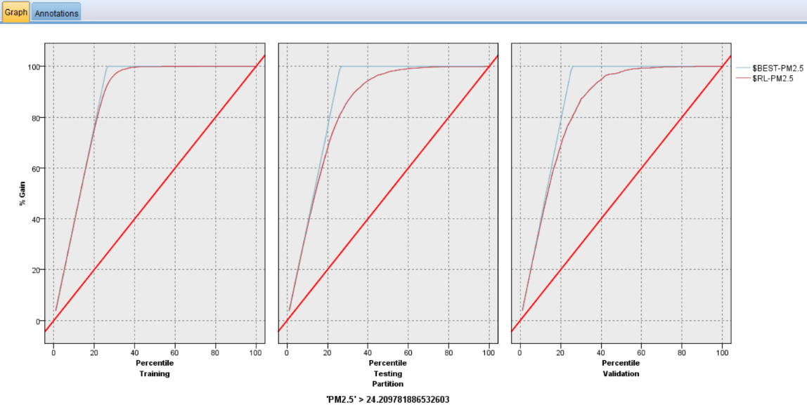

Random Forest Evaluation

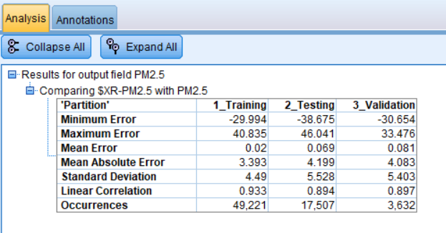

Auto Numeric Node Analysis

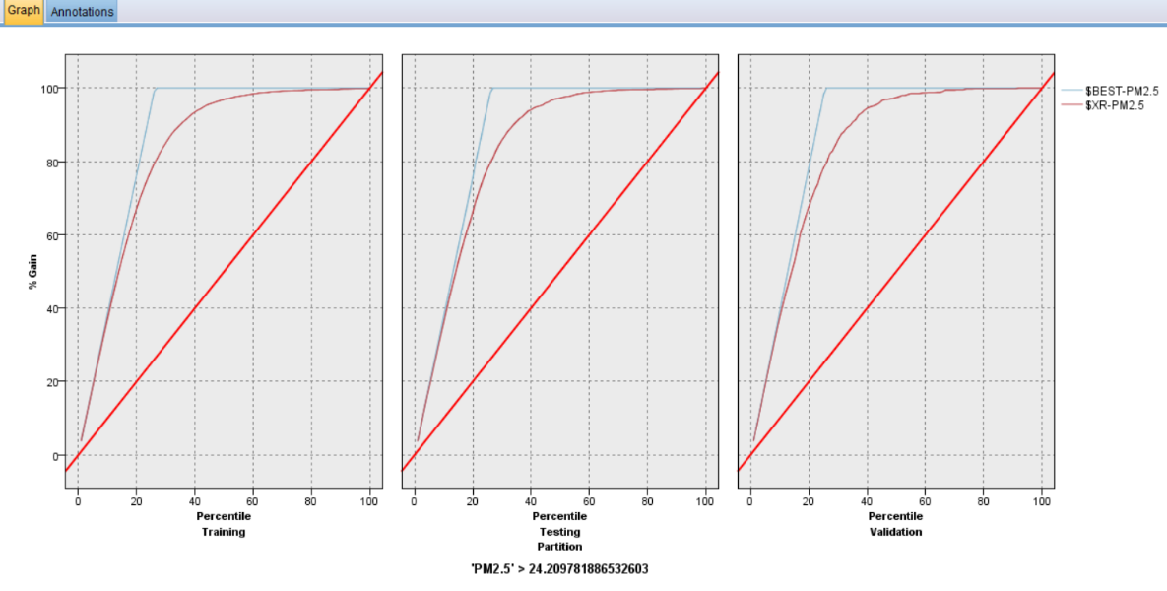

Auto Numeric Evaluation (Generalized Linear Regression)

From these evaluation and analysis results, we can see that our models have not bad overall quality, these pictures show us how good our models are.

By analyzing these models, our environment department may have a better understanding of the air quality and have a clearer view of what are the main pollutants in the air, also, how the external factors such as wind speed, humidity and so on, influence the PM2.5 concentration, and our physical health. In addition, by tracking the source of these pollutants, the environmental department may come up some solutions to deal with the ‘pollutant-producers.’ The data mining process reveals the relationship between air quality and chemicals, and it helps people to determine the priority when they want to deal with the pollutants.

* 1. **Iterate prior steps as required**

The data mining process is iterative, as we need to discover and try different algorithms to find the better result. In this case, for example, the first time I run the linear regression, the mean absolute error is a little high, so I thought if I try to do something with the data, does the result will be better? So, I iteratively build the linear regression model again, the difference is this time, the dataset was normalized. Also, in the data cleaning step, it is very often that we need to execute the cleaning operation iteratively, and then we can get the dataset that we want.

In general, the data mining job requires us to do plenty of iterative job, and then we can have a robust and accurate model.